Bill No: 0001/Mem/2026

Delhi Chapter of Indian Society of Pathologists and Microbiologists

Registered under the societies registration act 1860 (Delhi) No. S/4185/SDM/NW/2025

This is to certify that a total sum of INR/ USD _________________________________________ has been received from _________________________________________________________, in Cash/ by Cheque number ______________, dated__________, or via Online transfer No_____________________________, dated _____________, on account of his/ her application for Life Membership/ Ad Hoc Membership/ Overseas Membership application.

Authorized Signatories
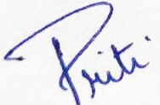
Treasurer
DC-IAPM
PAN No. DELD34086D Dated ____/_______/_______

